SOURCE CODE
LOGIN
<?php
session_start();
$logres=null;
include("header.php");
include("sidebar.php");
?>
<script type="text/javascript">
function validate()
{
if(document.form1.loginid.value=="")
{
alert("Enter Login ID");
document.form1.loginid.focus();
return false;
}
if(document.form1.password.value=="")
{
alert("Enter Password");
document.form1.loginid.focus();
return false;
}
}
</script>
<?php
include("dbconnection.php");
if(isset($_SESSION['empid']))
{
header("Location: empaccount.php");
}
if(isset($_SESSION['custid']))
{
header("Location: account.php");
}

if(isset($_POST['submit']))
{
$result = mysqli_query($con, "SELECT * FROM customer where emailid='$_POST[loginid]' AND password='$_POST[password]'");

if(mysqli_num_rows($result) == 1)
{

while($row = mysqli_fetch_array($result))
{
$_SESSION[custid] = $row[custid];
}

header("Location: account.php");
}
else
{
$logres = "Invalid User ID and password entered.." ;
}

}
?>

<div id="main">

<a name="TemplateInfo"></a>
<h1>Customer Login</h1>
<p>Please enter Login ID/ Email ID and Password to login website. </p>
<form id="form1" name="form1" method="post" action="" onsubmit="return validate()">
<table width="466" height="109" border="0">
<tr>
<th colspan="2" scope="row"><font color="#FF0000"><b><?php echo $logres; ?></b></font></th>
</tr>
<tr>
<th scope="row">Login ID</th>
<td><input name="loginid" type="text" id="loginid" size="30" /></td>
</tr>
<tr>
<th scope="row">Password <br /></th>
<td><input name="password" type="password" id="password" size="30" /></td>
</tr>
<tr>
<th scope="row">&nbsp;</th>
<td><input name="submit" type="submit" class="button" id="submit" value="Login" /></td>
</tr>
<tr>
<th scope="row">&nbsp;</th>
<td>&nbsp;</td>
</tr>
<tr>
<th scope="row">&nbsp;</th>
<td><strong><a href="forgotpassword.php">Forogot Password &gt;&gt;</a></strong></td>
</tr>
</table>
</form>
<p>&nbsp;</p>
</div>

<!-- wrap ends here -->
</div>

<?php
include("footer.php");
?>

Employee account
?php
include("header.php");
include("sidebar.php");
include("dbconnection.php");
if(isset($_SESSION['custid']))
{
header("Location: account.php");
}
?>
<div id="main">
<h3>Employee Home Page</h3>

<table width="539" border="1">
<tr>
<td width="382" height="45" align="center" valign="middle"><strong>No. of customers</strong></td>

<td width="141" align="center" valign="middle">
<strong>
<?php
$sqlcount = mysqli_query($con, "select * from customer");
echo mysqli_num_rows($sqlcount);
?>
</strong></td>
</tr>
<tr>
<td height="42" align="center" valign="middle"><strong>Number of vehicle service requests</strong></td>
<td align="center" valign="middle">
<strong>
<?php
$sqlcount = mysqli_query($con, "select * from service where status='Pending'");
echo mysqli_num_rows($sqlcount);
?>
</strong></td>
</tr>

<tr>
<td height="40" align="center" valign="middle"><strong>Spare parts orders</strong></td>
<td align="center" valign="middle">
<strong>
<?php
$sqlcount = mysqli_query($con,"select * from sparepartsorder where deliverydate='0000-00-00'");
echo mysqli_num_rows($sqlcount);
?>
</strong></td>
</tr>

<tr>
<td height="33" align="center" valign="middle"><strong>Used vehicles</strong></td>
<td align="center" valign="middle"><strong>
<?php
$sqlcount = mysqli_query($con,"select * from vehicle where status ='Pending'");
echo mysqli_num_rows($sqlcount);
?>
</strong></td>
</tr>
<tr>
<td height="40" align="center" valign="middle"><strong>No. of vehices in Vehicle store</strong></td>
<td align="center" valign="middle">
<strong>
<?php
$sqlcount = mysqli_query($con,"select * from vehiclestore where status !='Sold'");
echo mysqli_num_rows($sqlcount);
?>
</strong></td>
</tr>
<tr>
<td height="35" align="center" valign="middle"><strong>No. of test drive requests</strong></td>
<td align="center" valign="middle"> <strong>
<?php
$sqlcount = mysqli_query($con,"select * from testdrive where status ='Pending'");
echo mysqli_num_rows($sqlcount);
?>
</strong></td>
</tr>
</table>
</div>

<!-- wrap ends here -->
</div>

<?php
include("footer.php");
?>

Employee
<?php
include("header.php");
include("sidebar.php");
include("dbconnection.php");
?>
<script type="text/javascript">
function isNumberKey(evt)
{

var charCode = (evt.which) ? evt.which : event.keyCode
//alert(charCode);
if (charCode > 63 && charCode < 92 )
{
return true;
}
else if (charCode > 96 && charCode < 123 )
{
return true;
}
else
{
alert("should be alphabet");
return false;
}
}
function validate()
{
if(document.form1.fname.value=="")
{
alert("Enter First Name");
document.form1.fname.focus();
return false;
}
if(document.form1.lname.value=="")
{
alert("Enter Last Name");
document.form1.lname.focus();
return false;
}
if(document.form1.loginid.value=="")
{
alert("Enter Login ID");
document.form1.loginid.focus();
return false;
}
if(document.form1.password.value=="")
{
alert("Enter Password");
document.form1.password.focus();
return false;
}
if(document.form1.confpass.value=="")
{
alert("Please confirm the Password");
document.form1.confpass.focus();
return false;
}
if(document.form1.emailid.value=="")
{
alert("Enter Email ID");
document.form1.emailid.focus();
return false;
}
ml = document.form1.emailid.value;
pos1 = ml.indexOf("@")
pos = ml.indexOf(" ")
pos2 = (pos1+1)
server = ml.substring(pos2);
server_pos = server.lastIndexOf(".")
reqtype = server.substring(server_pos+1)
type_end = reqtype.substring(reqtype.length-1)

if(ml.length<8)
{
document.form1.emailid.focus();
document.form1.emailid.select();
alert("emailid length cannot be less than 8 characters");
return false;
}
if(ml.indexOf("@")==-1)
{
document.form1.emailid.focus();
document.form1.emailid.select();
alert("The emailid Address must contain '@' sign");
return false;
}
if(pos1<1)
{
document.form1.emailid.focus();
document.form1.emailid.select();
alert("emailid address cannot start with '@' sign");
return false;
}
if(ml.indexOf(".")==-1)
{
document.form1.emailid.focus();
document.form1.emailid.select();
alert("The emailid Address must contain '.' sign");
return false;
}
if(pos!=-1)
{
document.form1.emailid.focus();
document.form1.emailid.select();
alert("The emailid Address cannot contain spaces");
return false;
}
if(server.indexOf("@")!=-1)
{
document.form1.emailid.focus();
document.form1.emailid.select();
alert("A valid emailid must contain only one '@' sign");
return false;
}
if(server.indexOf(".")==0)
{
document.form1.emailid.focus();
document.form1.emailid.select();
alert("There should some text between '@' and '.' sign");
return false;
}
if(reqtype=="")
{
document.form1.emailid.focus();
document.form1.emailid.select();
alert("emailid Id should end with character(like .com,.net,.org)");
return false;
}
if(type_end.toUpperCase()<"A" || type_end.toUpperCase()>"Z")
{
document.form1.emailid.focus();
document.form1.emailid.select();
alert("emailid Id should not end with number or symbol");
return false;
}

if(document.form1.mobile.value=="")
{
alert("Enter Mobile Number");
document.form1.mobile.focus();
return false;
}
if(document.form1.phone.value=="")
{
alert("Enter Phone No");
document.form1.phone.focus();
return false;
}
if(document.form1.emptype.value=="")
{
alert("Select Employee Typt");
document.form1.emptype.focus();
return false;
}
}
</script>
<?php

if(isset($_POST["submit"]))
{
$sql ="insert into employee(fname,lname,loginid ,password,emailid,contactno1,contactno2,employeetype) values('$_POST[fname]','$_POST[lname]','$_POST[loginid]','$_POST[password]','$_POST[emailid]','$_POST[mobile]','$_POST[phone]','$_POST[emptype]')";

if (!mysql_query($sql,$con))
{
die('Error: ' . mysql_error());
}
$ctins = mysql_affected_rows();
}

if(isset($_POST["update"]))
{
$sql ="update employee set fname='$_POST[fname]',lname='$_POST[lname]',loginid='$_POST[loginid]', emailid='$_POST[emailid]',contactno1='$_POST[mobile]',contactno2='$_POST[phone]' where employeeid='$_GET[empid]'";

if (!mysql_query($sql,$con))
{
die('Error: ' . mysql_error());
}
$ctins = mysql_affected_rows();
}
?>
<?php
if(isset($_GET['empid']))
{
$sql = mysql_query("select * from employee where employeeid='$_GET[empid]'");
$row = mysql_fetch_array($sql);
}
?>

<div id="main">

<a name="TemplateInfo"></a>
<h1>Add Employees</h1>
<h3><center><a href="viewemployees.php">View Employees</a></center></h3>
<?php
if($ctins == 1)
{
if(isset($_GET['empid']))
{
echo "<center><b>Employees account Updated successfully...</b></center><br>";
}
else
{
echo "<center><b>Employees account created successfully...</b></center><br>";
}
}
else
{
?>
<form id="form1" name="form1" method="post" action="" onsubmit="return validate()">
<table width="371" border="0">
<tr>
<th width="169" height="33" scope="row">First Name</th>
<td width="140">
<label for="fname"></label>
<input type="text" name="fname" value="<?php echo $row['fname']; ?>" id="fname" onKeyPress="return isNumberKey(event)"/>
</td>
</tr>
<tr>
<th height="37" scope="row">Last Name
<label for="lname"></label></th>
<td><input type="text" name="lname" value="<?php echo $row['lname']; ?>" id="lname" onKeyPress="return isNumberKey(event)" /></td>
</tr>
<tr>
<th height="36" scope="row">Login Id</th>
<td><label for="loginid"></label>
<input type="text" name="loginid" id="loginid" value="<?php echo $row['loginid']; ?>" /></td>
</tr>
<tr>
<th height="34" scope="row">Password</th>
<td><label for="password"></label>
<input type="password" name="password" <?php if(isset($_GET['empid'])) { ?> readonly="readonly" <?php } ?> id="password" /></td>
</tr>
<tr>
<th height="40" scope="row">Confirm Password</th>
<td><label for="confpass"></label>
<input type="password" name="confpass" <?php if(isset($_GET['empid'])) { ?> readonly="readonly" <?php } ?> id="confpass" /></td>
</tr>
<tr>
<th height="37" scope="row">Email ID</th>
<td><label for="emailid"></label>
<input type="text" name="emailid" value="<?php echo $row['emailid']; ?>" id="emailid" /></td>
</tr>
<tr>
<th height="37" scope="row">Mobile No</th>
<td><label for="mobile"></label>
<input type="text" name="mobile" value="<?php echo $row['contactno1']; ?>" id="mobile" onKeypress="if (event.keyCode < 45 || event.keyCode > 57) event.returnValue = false;"/></td>
</tr>
<tr>
<th scope="row">Phone No</th>
<td><input type="text" name="phone" value="<?php echo $row['contactno2']; ?>" id="phone" onKeypress="if (event.keyCode < 45 || event.keyCode > 57) event.returnValue = false;"/>
<label for="phone2"></label></td>
</tr>
<tr>
<th scope="row">Employee Type</th>
<td><label for="emptype"></label>
<label for="emptype2"></label>
<select name="emptype" id="emptype2">
<option value="Employees">Employees</option>
<option value="Administrator">Administrator</option>
</select></td>
</tr>
<tr>
<th scope="row">&nbsp;</th>
<td><br /><?php if(isset($_GET['empid'])) { ?> <input type="submit" name="update" id="submit" value="Update Employees" /><?php } else { ?> <input type="submit" name="submit" id="submit" value="Add Employees" /><?php } ?></td>
</tr>
</table>
</form>
<?php
}
?>
<p>&nbsp;</p>
<br />

</div>

<!-- wrap ends here -->
</div>

<?php
include("footer.php");
?>

REGISTRATION
<?php
session_start();
$ctins=null;
include("header.php");
include("sidebar.php");
?>

<script type="text/javascript">
function isNumberKey(evt)
{

var charCode = (evt.which) ? evt.which : event.keyCode
//alert(charCode);
if (charCode > 63 && charCode < 92 )
{
return true;
}
else if (charCode > 96 && charCode < 123 )
{
return true;
}
else
{
alert("should be alphabet");
return false;
}
}
function validate()
{
if(document.form1.fname.value=="")
{
alert("Enter First Name");
document.form1.fname.focus();
return false;
}
if(document.form1.lname.value=="")
{
alert("Enter Last Name");
document.form1.lname.focus();
return false;
}
if(document.form1.emailid.value=="")
{
alert("Enter Email ID");
document.form1.emailid.focus();
return false;
}
ml = document.form1.emailid.value;
pos1 = ml.indexOf("@")
pos = ml.indexOf(" ")
pos2 = (pos1+1)
server = ml.substring(pos2);
server_pos = server.lastIndexOf(".")
reqtype = server.substring(server_pos+1)
type_end = reqtype.substring(reqtype.length-1)

if(ml.length<8)
{
document.form1.emailid.focus();
document.form1.emailid.select();
alert("emailid length cannot be less than 8 characters");
return false;
}
if(ml.indexOf("@")==-1)
{
document.form1.emailid.focus();
document.form1.emailid.select();
alert("The emailid Address must contain '@' sign");
return false;
}
if(pos1<1)
{
document.form1.emailid.focus();
document.form1.emailid.select();
alert("emailid address cannot start with '@' sign");
return false;
}
if(ml.indexOf(".")==-1)
{
document.form1.emailid.focus();
document.form1.emailid.select();
alert("The emailid Address must contain '.' sign");
return false;
}
if(pos!=-1)
{
document.form1.emailid.focus();
document.form1.emailid.select();
alert("The emailid Address cannot contain spaces");
return false;
}
if(server.indexOf("@")!=-1)
{
document.form1.emailid.focus();
document.form1.emailid.select();
alert("A valid emailid must contain only one '@' sign");
return false;
}
if(server.indexOf(".")==0)
{
document.form1.emailid.focus();
document.form1.emailid.select();
alert("There should some text between '@' and '.' sign");
return false;
}
if(reqtype=="")
{
document.form1.emailid.focus();
document.form1.emailid.select();
alert("emailid Id should end with character(like .com,.net,.org)");
return false;
}
if(type_end.toUpperCase()<"A" || type_end.toUpperCase()>"Z")
{
document.form1.emailid.focus();
document.form1.emailid.select();
alert("emailid Id should not end with number or symbol");
return false;
}

if(document.form1.password.value=="")
{
alert("Enter Password");
document.form1.password.focus();
return false;
}
if(document.form1.confpass.value=="")
{
alert("Please confirm the Password");
document.form1.confpass.focus();
return false;
}
if(document.form1.address.value=="")
{
alert("Enter the Address");
document.form1.address.focus();
return false;
}
if(document.form1.city.value=="")
{
alert("Enter the City");
document.form1.city.focus();
return false;
}
if(document.form1.zip.value=="")
{
alert("Enter the Zip");
document.form1.zip.focus();
return false;
}
if(document.form1.phone.value=="")
{
alert("Enter Phone No");
document.form1.phone.focus();
return false;
}
if(document.form1.mobile.value=="")
{
alert("Enter Mobile Number");
document.form1.mobile.focus();
return false;
}
}
</script>
<?php
include("dbconnection.php");
if(isset($_SESSION['empid']))
{
header("Location: empaccount.php");
}
if(isset($_SESSION['custid']))
{
header("Location: account.php");
}
$dt= date("Y-m-d");
if(isset($_POST["submit"]))
{
$sql ="insert into customer(fname,lname,emailid ,password,createddate,contactno1,contactno2,address,city,zipcode) values('$_POST[fname]','$_POST[lname]','$_POST[email]','$_POST[password]','$dt','$_POST[phone]','$_POST[mobile]','$_POST[address]','$_POST[city]','$_POST[zipcode]')";
if (!mysqli_query($con,$sql))
{
die('Error: ' . mysqli_error());
}
$ctins = mysqli_affected_rows($sql);
}
?>

<div id="main">

<a name="TemplateInfo"></a>
<h1>Customer Registration</h1>

<?php
if($ctins == 1)
{
echo "<center><b>Custmer registered Successfully...</b></center><br>";
echo "<center><b><a href='login.php'>Click here to Login.</a></b></center>";
}
else
{
?>
<form id="form1" name="form1" method="post" action="" onsubmit="return validate()">
<table width="522" border="0">
<tr bgcolor="#CCFFFF">
<th height="33" scope="row" align="left">User information:</th>
<td>&nbsp;</td>
</tr>
<tr>
<th width="170" height="33" scope="row">First Name</th>
<td width="247">
<label for="lname"></label>
<input name="fname" type="text" id="fname" size="35" onKeyPress="return isNumberKey(event)"/>
</td>
</tr>
<tr>
<th height="37" scope="row">Last Name
<label for="lname"></label></th>
<td><input name="lname" type="text" id="lname" size="35" onKeyPress="return isNumberKey(event)" /></td>
</tr>
<tr>
<th height="36" scope="row">Email Id</th>
<td><label for="email"></label>
<input name="email" type="text" id="email" size="35" /></td>
</tr>
<tr>
<th height="34" scope="row">Password</th>
<td><label for="password"></label>
<input name="password" type="password" id="password" size="35" /></td>
</tr>
<tr>
<th height="40" scope="row">Confirm Password</th>
<td><label for="confpass"></label>
<input name="confpass" type="password" id="confpass" size="35" /></td>
</tr>
<tr align="left" bgcolor="#CCFFFF">
<th height="29" colspan="2" scope="row"><u>Contact information</u></th>
</tr>
<tr>
<th height="37" scope="row">Address</th>
<td><textarea name="address" cols="35" id="address"></textarea></td>
</tr>
<tr>
<th height="37" scope="row">City</th>
<td><input name="city" type="text" id="city" size="35" /></td>
</tr>
<tr>
<th height="37" scope="row">Zip code</th>
<td><input name="zipcode" type="text" id="zipcode" size="35" onKeypress="if (event.keyCode < 45 || event.keyCode > 57) event.returnValue = false;"/></td>
</tr>
<tr>
<th height="37" scope="row">Phone No</th>
<td><label for="date"></label>
<input name="phone" type="text" id="phone" size="35" onKeypress="if (event.keyCode < 45 || event.keyCode > 57) event.returnValue = false;"/></td>
</tr>
<tr>
<th scope="row">Mobile No</th>
<td><label for="mobile"></label>
<input name="mobile" type="text" id="mobile" size="35" onKeypress="if (event.keyCode < 45 || event.keyCode > 57) event.returnValue = false;"/></td>
</tr>
<tr>
<th scope="row">&nbsp;</th>
<td><br /> <input type="submit" name="submit" id="submit" value="Register" /></td>
</tr>
</table>
</form>
<?php
}
?>
<p>&nbsp;</p>
<br />

</div>

<!-- wrap ends here -->
</div>

<?php
include("footer.php");
?>
}
?>
<p>&nbsp;</p>
<br />

</div>

<!-- wrap ends here -->
</div>

<?php
include("footer.php");
?>

SOLD VEHICLES
<?php
include("header.php");

include("sidebar.php");
include("dbconnection.php");
$sql = mysql_query("select * from vehiclestore where status = 'Sold'");

?>

<div id="main">
<h3>Vehicle store</h3>

<div id="wrapper">
<?php
while($row = mysql_fetch_array($sql))
{
?>
<div id="products">
<table border="0">
<tr>
<td><img src="upload/<?= $row['images']; ?>" width="122" height="95" align="left" /><strong>Vehicle Name:</strong> <?= $row['vehname']; ?><br />
<strong>Model:</strong> <?= $row['model']; ?> <br />
<strong> Brand:</strong><?= $row['brand']; ?><br />
<strong>Estimated price: </strong>Rs.<?= $row['estprice']; ?><br />
<strong> <?php echo"<a href='soldvahiclemore.php?vahicleid=$row[vehicleid]'>More&gt;&gt;</a></strong><br />"; ?>
<br />
</p>
</td></tr></table>
</div>
<?
}
?>
</div>

<!--<table width="538" border="1">

<tr>
<td width="268">
<p><img src="images/vehicle.jpg" width="122" height="95" align="left" /><strong>Vehicle Name:</strong> <?= $row['vehname']; ?><br />
<strong>Model:</strong> <?= $row['vehname']['0']; ?> <br />
<strong> Brand:</strong> tyere<br />
<strong>Estimated price: </strong>Rs.20000<br />
<strong> <a href="vehiclestoremore.php">More&gt;&gt;</a></strong><br />
<br />
</p></td>
<td width="246"><p><img src="images/vehicle.jpg" width="122" height="95" align="left" /><strong>Vehicle Name:</strong> <?= $row['vehname']; ?><br />
<strong>Model:</strong> <?= $row['vehname']['1']; ?> <br />
<strong> Brand:</strong> tyere<br />
<strong>Estimated price: </strong>Rs.20000<br />
<strong> <a href="vehiclestoremore.php">More&gt;&gt;</a></strong><br />
<br />
</p></td>
</tr>
<?
// }
?>
<tr>
<td>&nbsp;<p><img src="images/vehicle.jpg" width="122" height="95" align="left" /><strong>Vehicle Name:</strong> <?= $row['vehname']; ?><br />
<strong>Model:</strong> <?= $row['vehname']; ?> <br />
<strong> Brand:</strong> tyere<br />
<strong>Estimated price: </strong>Rs.20000<br />
<strong> <a href="vehiclestoremore.php">More&gt;&gt;</a></strong><br />
<br />
</p></td>
<td>&nbsp;<p><img src="images/vehicle.jpg" width="122" height="95" align="left" /><strong>Vehicle Name:</strong> <?= $row['vehname']; ?><br />
<strong>Model:</strong> <?= $row['vehname']; ?> <br />
<strong> Brand:</strong> tyere<br />
<strong>Estimated price: </strong>Rs.20000<br />
<strong> <a href="vehiclestoremore.php">More&gt;&gt;</a></strong><br />
<br />
</p></td>
</tr>
<tr>
<td>&nbsp;<p><img src="images/vehicle.jpg" width="122" height="95" align="left" /><strong>Vehicle Name:</strong> <?= $row['vehname']; ?><br />
<strong>Model:</strong> <?= $row['vehname']; ?> <br />
<strong> Brand:</strong> tyere<br />
<strong>Estimated price: </strong>Rs.20000<br />
<strong> <a href="vehiclestoremore.php">More&gt;&gt;</a></strong><br />
<br />
</p></td>
<td>&nbsp;<p><img src="images/vehicle.jpg" width="122" height="95" align="left" /><strong>Vehicle Name:</strong> <?= $row['vehname']; ?><br />
<strong>Model:</strong> <?= $row['vehname']; ?> <br />
<strong> Brand:</strong> tyere<br />
<strong>Estimated price: </strong>Rs.20000<br />
<strong> <a href="vehiclestoremore.php">More&gt;&gt;</a></strong><br />
<br />
</p></td>
</tr> <tr>
<td>&nbsp;<p><img src="images/vehicle.jpg" width="122" height="95" align="left" /><strong>Vehicle Name:</strong> <?= $row['vehname']; ?><br />
<strong>Model:</strong> <?= $row['vehname']; ?> <br />
<strong> Brand:</strong> tyere<br />
<strong>Estimated price: </strong>Rs.20000<br />
<strong> <a href="vehiclestoremore.php">More&gt;&gt;</a></strong><br />
<br />
</p></td>
<td>&nbsp;<p><img src="images/vehicle.jpg" width="122" height="95" align="left" /><strong>Vehicle Name:</strong> <?= $row['vehname']; ?><br />
<strong>Model:</strong> <?= $row['vehname']; ?> <br />
<strong> Brand:</strong> tyere<br />
<strong>Estimated price: </strong>Rs.20000<br />
<strong> <a href="vehiclestoremore.php">More&gt;&gt;</a></strong><br />
<br />
</p></td>
</tr>
</table>-->
</div>

<!-- wrap ends here -->
</div>

<?php
include("footer.php");
?>

SPARE PARTS
<?php
session_start();
include("header.php");
include("sidebar.php");
include("dbconnection.php");
?>
<script type="text/javascript">
function isNumberKey(evt)
{

var charCode = (evt.which) ? evt.which : event.keyCode
//alert(charCode);
if (charCode > 63 && charCode < 92 )
{
return true;
}
else if (charCode > 96 && charCode < 123 )
{
return true;
}
else
{
alert("should be alphabet");
return false;
}
}
function validate()
{
if(document.form1.sparename.value=="")
{
alert("Enter Sparepart Name");
document.form1.sparename.focus();
return false;
}
if(document.form1.sparetype.value=="")
{
alert("Enter Sparepart Type");
document.form1.sparetype.focus();
return false;
}
if(document.form1.spareno.value=="")
{
alert("Enter Sparepart Number");
document.form1.spareno.focus();
return false;
}
if(document.form1.sparecost.value=="")
{
alert("Enter Sparepart Cost");
document.form1.sparecost.focus();
return false;
}
if(document.form1.description.value=="")
{
alert("Enter Sparepart Description");
document.form1.description.focus();
return false;
}

}
</script>
<?php
if(isset($_POST["submit"]))
{
move_uploaded_file($_FILES["file"]["tmp_name"],
"upload/" . $_FILES["file"]["name"]);
$img = $_FILES["file"]["name"];
$sql ="insert into spareparts(name,type,cost,sparepartno,description,image) values('$_POST[sparename]','$_POST[sparetype]','$_POST[sparecost]','$_POST[spareno]','$_POST[description]','$img')";
$ctins = 1;
if (!mysql_query($sql,$con))
{
die('Error: ' . mysql_error());
}
}
if(isset($_POST["update"]))
{
move_uploaded_file($_FILES["file"]["tmp_name"],"upload/" . $_FILES["file"]["name"]);
$img = $_FILES["file"]["name"];
if($img=="")
{
$sql ="update spareparts set name='$_POST[sparename]',type='$_POST[sparetype]',cost='$_POST[sparecost]',sparepartno='$_POST[spareno]',description='$_POST[description]' where spid='$_GET[sparepartid]'";
}
else
{
$sql ="update spareparts set name='$_POST[sparename]',type='$_POST[sparetype]',cost='$_POST[sparecost]',sparepartno='$_POST[spareno]',description='$_POST[description]',image='$img' where spid='$_GET[sparepartid]'";
}
$ctins = 1;
if (!mysql_query($sql,$con))
{
die('Error: ' . mysql_error());
}
}

?>
<?php
$sql = mysql_query("select * from spareparts where spid = '$_GET[sparepartid]'");
$row = mysql_fetch_array($sql);
?>

<?php
if($ctins == 1)
{
if(isset($_GET['sparepartid'])){
echo "<center><b>Spare Parts Updated Successfully...</b></center><br>";
}
else
{
echo "<center><b>Spare Parts Added Successfully...</b></center><br>";
}
}
else
{
?>

<div id="main">

<a name="TemplateInfo"></a>
<h1>Add spare parts</h1>
<h3><center><a href="viewspareparts.php">View spare parts</a></center></h3>
<form id="form1" name="form1" method="post" action="" enctype="multipart/form-data" onsubmit="return validate()">
<table width="489" border="0">
<tr>
<th width="169" height="33" scope="row">Sparepart Name</th>
<td width="140">
<label for="fname"></label>
<label for="custname"></label>
<label for="sparename"></label>
<input name="sparename" type="text" value="<?php echo $row['name']; ?>" id="sparename" size="30" onKeyPress="return isNumberKey(event)"/></td>
</tr>
<tr>
<th height="37" scope="row">Sparepart Type
<label for="lname"></label></th>
<td><label for="vehname"></label>
<label for="sparetype"></label>
<input name="sparetype" type="text" value="<?php echo $row['type']; ?>" id="sparetype" size="30" /></td>
</tr>
<tr>
<th height="36" scope="row">Sparepart No</th>
<td>
<input name="spareno" type="text" value="<?php echo $row['sparepartno']; ?>" id="spareno" size="30" />
</td>
</tr>
<tr>
<th height="37" scope="row">Sparepart Cost
<label for="lname"></label></th>
<td><label for="vehname"></label>
<label for="sparecost"></label>
<input type="text" name="sparecost" value="<?php echo $row['cost']; ?>" id="sparecost" size="30" onKeypress="if (event.keyCode < 45 || event.keyCode > 57) event.returnValue = false;"/></td>
</tr>
<tr>
<th height="34" scope="row">Description </th>
<td><label for="password"></label>
<label for="date"></label>
<label for="description"></label>
<textarea name="description" id="description"><?php echo $row['description']; ?></textarea></td>
</tr>
<tr>
<th height="40" scope="row">Image</th>
<td><label for="confpass"></label>
<label for="images"></label>
<label for="address"></label>
<label for="image"></label>
<input type="file" name="file" id="file" />
<br />
<?php
if(isset($_GET['sparepartid']))
{
?>
<img src="upload/<?php echo $row['image']; ?>" width="150" height="150" />
<?php
}
?></td>
</tr>
<tr>
<th scope="row">&nbsp;</th>
<td><?php if(isset($_GET['sparepartid'])) { ?><input type="submit" name="update" id="submit" value="Update Spare parts" /> <?php } else { ?> <input type="submit" name="submit" id="submit" value="Submit" /><?php } ?></td>
</tr>
<tr>
<th scope="row">&nbsp;</th>
<td>&nbsp;</td>
</tr>
</table>
</form>
<?php
}
?>
<p>&nbsp;</p>

</div>

<!-- wrap ends here -->
</div>

<?php
include("footer.php");
?>

Spare parts order
<?php
include("header.php");

include("sidebar.php");
include("dbconnection.php");
$sql = mysql_query("select * from spareparts where spid='$_GET[sparepartid]'");
$row = mysql_fetch_array($sql);
if(!isset($_SESSION[custid]))
{
header("Location: login.php");
}
?>

<div id="main">
<h3>Spare parts order</h3>

<form id="form1" name="form1" method="post" action="orderedspareparts.php">
<table width="534" border="1">
<tr>
<td colspan="2"><strong>Spare part name: </strong>abcd spare</td>
</tr>
<tr>
<td width="142"><img src="upload/<?php echo $row['image']; ?>" width="196" height="153" /></td>
<td width="352" valign="top"><p><strong>Spare parts type : <?php echo $row['type']; ?></strong>a123 </p>
<p><strong>Cost : </strong><?php echo $row['cost']; ?></p>
<p><strong>Spare parts serial No. :</strong> <?php echo $row['sparepartno']; ?></p>
<p>&nbsp;</p></td>
</tr>
<?php
$result = mysql_query("select * from customer where custid='$_SESSION[custid]'");
$res = mysql_fetch_array($result);
?>
<tr>
<td colspan="2"><strong>Customer Information:</strong></td>
</tr>
<tr>
<td><strong>Customer name :</strong></td>
<td valign="top"><?php echo $res['fname'].$res['lname']; ?></td>
</tr>
<tr>
<td><strong>Email ID:</strong></td>
<td valign="top"><?php echo $res['emailid']; ?></td>
</tr>
<tr>
<td><strong>Contact No.:</strong></td>
<td valign="top"><?php echo $res['contactno1']; ?></td>
</tr>
<tr>
<td><strong>No. Of Items</strong></td>
<td valign="top"><label for="address"></label>
<input type="text" name="noofitems" id="noofitems" onKeypress="if (event.keyCode < 45 || event.keyCode > 57) event.returnValue = false;"/><input type="hidden" name="spid" value="<?php echo $row['spid']; ?>" /></td>
</tr>
<tr>
<td>&nbsp;</td>
<td valign="top">&nbsp;</td>
</tr>
<tr>
<td>&nbsp;</td>
<td valign="top">
<input type="submit" name="submit" id="submit" value="Order products" />
</form></td>
</tr>
</table>
</div>
<!-- wrap ends here -->
</div>

<?php
include("footer.php");
?>

Vehicle store
<?php
session_start();
include("header.php");
if(isset($_SESSION['empid']))
{
header("Location: empaccount.php");
}
include("sidebar.php");
include("dbconnection.php");
$sql = mysqli_query($con,"select * from vehiclestore where status != 'Sold'");

?>

<div id="main">
<h3>Vehicle store</h3>

<div id="wrapper">
<?php
while($row = mysqli_fetch_array($sql))
{
?>
<div id="products">
<table width="497" border="0">
<tr>
<td><img src="upload/<?= $row['images']; ?>" width="122" height="95" align="left" /><strong>Vehicle Name:</strong> <?= $row['vehname']; ?><br />
<strong>Model:</strong> <?= $row['model']; ?> <br />
<strong> Brand:</strong><?= $row['brand']; ?><br />
<strong>Estimated price: </strong>Rs.<?= $row['estprice']; ?><br />
<strong> <?php echo "<br><a href='testdrive.php?vahicleidnum=$row[vehicleid]'>Test Drive&gt;&gt;</a> &nbsp; &nbsp; &nbsp; &nbsp; &nbsp; &nbsp; &nbsp; &nbsp; &nbsp; &nbsp; &nbsp; <a href='vehiclestoremore.php?vahicleid=$row[vehicleid]'>More&gt;&gt;</a></strong><br />"; ?>
<br />
</p>
</td></tr></table>
</div>
<?php
}
?>
</div>

<!--<table width="538" border="1">

<tr>
<td width="268">
<p><img src="images/vehicle.jpg" width="122" height="95" align="left" /><strong>Vehicle Name:</strong> <?= $row['vehname']; ?><br />
<strong>Model:</strong> <?= $row['vehname']['0']; ?> <br />
<strong> Brand:</strong> tyere<br />
<strong>Estimated price: </strong>Rs.20000<br />
<strong> <a href="vehiclestoremore.php">More&gt;&gt;</a></strong><br />
<br />
</p></td>
<td width="246"><p><img src="images/vehicle.jpg" width="122" height="95" align="left" /><strong>Vehicle Name:</strong> <?= $row['vehname']; ?><br />
<strong>Model:</strong> <?= $row['vehname']['1']; ?> <br />
<strong> Brand:</strong> tyere<br />
<strong>Estimated price: </strong>Rs.20000<br />
<strong> <a href="vehiclestoremore.php">More&gt;&gt;</a></strong><br />
<br />
</p></td>
</tr>
<?
// }
?>
<tr>
<td>&nbsp;<p><img src="images/vehicle.jpg" width="122" height="95" align="left" /><strong>Vehicle Name:</strong> <?= $row['vehname']; ?><br />
<strong>Model:</strong> <?= $row['vehname']; ?> <br />
<strong> Brand:</strong> tyere<br />
<strong>Estimated price: </strong>Rs.20000<br />
<strong> <a href="vehiclestoremore.php">More&gt;&gt;</a></strong><br />
<br />
</p></td>
<td>&nbsp;<p><img src="images/vehicle.jpg" width="122" height="95" align="left" /><strong>Vehicle Name:</strong> <?= $row['vehname']; ?><br />
<strong>Model:</strong> <?= $row['vehname']; ?> <br />
<strong> Brand:</strong> tyere<br />
<strong>Estimated price: </strong>Rs.20000<br />
<strong> <a href="vehiclestoremore.php">More&gt;&gt;</a></strong><br />
<br />
</p></td>
</tr>
<tr>
<td>&nbsp;<p><img src="images/vehicle.jpg" width="122" height="95" align="left" /><strong>Vehicle Name:</strong> <?= $row['vehname']; ?><br />
<strong>Model:</strong> <?= $row['vehname']; ?> <br />
<strong> Brand:</strong> tyere<br />
<strong>Estimated price: </strong>Rs.20000<br />
<strong> <a href="vehiclestoremore.php">More&gt;&gt;</a></strong><br />
<br />
</p></td>
<td>&nbsp;<p><img src="images/vehicle.jpg" width="122" height="95" align="left" /><strong>Vehicle Name:</strong> <?= $row['vehname']; ?><br />
<strong>Model:</strong> <?= $row['vehname']; ?> <br />
<strong> Brand:</strong> tyere<br />
<strong>Estimated price: </strong>Rs.20000<br />
<strong> <a href="vehiclestoremore.php">More&gt;&gt;</a></strong><br />
<br />
</p></td>
</tr> <tr>
<td>&nbsp;<p><img src="images/vehicle.jpg" width="122" height="95" align="left" /><strong>Vehicle Name:</strong> <?= $row['vehname']; ?><br />
<strong>Model:</strong> <?= $row['vehname']; ?> <br />
<strong> Brand:</strong> tyere<br />
<strong>Estimated price: </strong>Rs.20000<br />
<strong> <a href="vehiclestoremore.php">More&gt;&gt;</a></strong><br />
<br />
</p></td>
<td>&nbsp;<p><img src="images/vehicle.jpg" width="122" height="95" align="left" /><strong>Vehicle Name:</strong> <?= $row['vehname']; ?><br />
<strong>Model:</strong> <?= $row['vehname']; ?> <br />
<strong> Brand:</strong> tyere<br />
<strong>Estimated price: </strong>Rs.20000<br />
<strong> <a href="vehiclestoremore.php">More&gt;&gt;</a></strong><br />
<br />
</p></td>
</tr>
</table>-->
</div>

<!-- wrap ends here -->
</div>

<?php
include("footer.php");
?>

VIEW BILLING
<?php
include("header.php");
include("sidebar.php");

include("dbconnection.php");

$result= mysql_query("select * from billing");
?>

<div id="main">

<a name="TemplateInfo"></a>
<h1>Billing</h1>
<?php
if($ctins == 1)
{
echo "<center><b>Employees account created successfully...</b></center><br>";
echo "<center><b><a href='emplogin.php'>Click here to Login.</a></b></center>";
}
else
{
?>
<form id="form1" name="form1" method="post" action="">
<table width="686" border="1">
<tr>
<th scope="col">Bill No</th>
<th scope="col">Service ID</th>
<th scope="col">Particulars</th>
<th scope="col">Service Cost</th>
<th scope="col">Date</th>
<th scope="col">Advance</th>
</tr>
<?php
while($arrrec= mysql_fetch_array($result))
{
echo" <tr>
<td>&nbsp; $arrrec[billingno]</td>
<td>&nbsp; $arrrec[serviceid]</td>
<td>&nbsp; $arrrec[particulars]</td>
<td>&nbsp; $arrrec[scost]</td>
<td>&nbsp; $arrrec[date]</td>
<td>&nbsp; $arrrec[paidstatus]</td>
</tr>";
}
?>
</table>
</form>
<?php
}
?>
<p>&nbsp;</p>
<br />

</div>

<!-- wrap ends here -->
</div>

<?php
include("footer.php");
?>

VIEW BUY SPARE PARTS
<?php
session_start();
include("header.php");
include("sidebar.php");

include("dbconnection.php");
if(isset($_GET["ordid"]))
{
$dt= date("Y-m-d");
mysqli_query("UPDATE sparepartsorder SET status='Delivered',deliverydate='$dt' where sporderid='$_GET[ordid]'");
}

if(isset($_SESSION['custid']))
{
$result= mysqli_query($con,"select * from sparepartsorder where custid='$_SESSION[custid]'");
}
else
{
$result= mysqli_query($con,"select * from sparepartsorder");
}
?>

<div id="main">

<a name="TemplateInfo"></a>
<h1>View purchased Vehicles</h1>

<form id="form1" name="form1" method="post" action="">
<table width="657" border="1">
<tr>
<th width="67" scope="col">Order ID</th>
<th width="221" scope="col">Spare Parts details</th>
<th width="138" scope="col">Customer<br />
details</th>
<th width="81" scope="col">Date</th>
<th width="45" scope="col">No. of Items</th>

<th width="46" scope="col">Status</th>

</tr>
<?php
while($arrrec= mysqli_fetch_array($result))
{
$result1= mysqli_query($con,"select * from vehiclestore where vehicleid='$arrrec[vehicleid]'");
$arrrec1= mysqli_fetch_array($result1);

$result2= mysqli_query($con,"select * from spareparts where spid='$arrrec[spid]'");
$arrrec2= mysqli_fetch_array($result2);

$result3= mysqli_query($con,"select * from customer where custid='$arrrec[custid]'");
$arrrec3= mysqli_fetch_array($result3);
echo" <tr>
<td>&nbsp; $arrrec[sporderid]</td>
<td><img src='upload/$arrrec2[image]' height='75' width='75' align='left'>
Name: <b>$arrrec2[name]</b><br>
Type: <b>$arrrec2[type]</b><br>
Cost: Dhs. <b>$arrrec2[cost]</b><br>
Spareparts No: <b>$arrrec2[sparepartno]</b><br>
</td>
<td>&nbsp;";
echo "<strong>Name: </strong>".$arrrec3['fname']. " ". $arrrec3['lname']."<br>";
echo "<strong>Contact No.: </strong>". $arrrec3['contactno1'];
echo " </td>
<td>&nbsp;<strong>Order date:</strong> <br>&nbsp;$arrrec[orderdate]&nbsp;<hr>
&nbsp;<strong>Delivered date:</strong> <br>&nbsp;$arrrec[deliverydate]</td>
<td>&nbsp; $arrrec[noofitems]</td>
<td>&nbsp; <strong>$arrrec[status]</strong><br>";
if(!isset($_SESSION['custid']))
{
if($arrrec['status'] == "Pending")
{
echo "<a href='viewbuyspareparts.php?ordid=$arrrec[sporderid]'>Delivered</a>";
}
}
echo "</td></tr>";
}
?>
</table>
</form>
<p>&nbsp;</p>
<br />

</div>

<!-- wrap ends here -->
</div>

<?php
include("footer.php");
?>>
</div>

VIEW BUY VEHICLES
<?php
session_start();
$ctins=null;
include("header.php");
include("sidebar.php");

include("dbconnection.php");

$dt= date("Y-m-d");
if(isset($_GET["purchaseid"]))
{

mysqli_query("UPDATE booking SET paymenttype='Delivered',deliverydate='$dt' where purchaseid='$_GET[purchaseid]'");
}
if(isset($_SESSION['custid']))
{
$result= mysqli_query($con,"select * from booking where custid='$_SESSION[custid]'");
}
else
{
$result= mysqli_query($con,"select * from booking");
}
?>

<div id="main">

<a name="TemplateInfo"></a>
<h1>View purchased Vehicles</h1>
<?php
if($ctins == 1)
{
echo "<center><b>Employees account created successfully...</b></center><br>";
echo "<center><b><a href='emplogin.php'>Click here to Login.</a></b></center>";
}
else
{
?>
<form id="form1" name="form1" method="post" action="">
<table width="754" border="1">
<tr>
<th width="81" scope="col">Purchase ID</th>
<th width="103" scope="col">Vehicle Name</th>
<th width="135" scope="col">Customer details</th>
<th width="92" scope="col">Date</th>
<th width="105" scope="col">Comments</th>
<th width="87" scope="col">Paid amount</th>
<th width="105" scope="col">Status</th>

</tr>
<?php
while($arrrec= mysqli_fetch_array($result))
{
$result1= mysqli_query($con,"select * from vehiclestore where vehicleid='$arrrec[vehicleid]'");
$arrrec1= mysqli_fetch_array($result1);

$result2= mysqli_query($con,"select * from customer where custid='$arrrec[custid]'");
$arrrec2= mysqli_fetch_array($result2);
echo" <tr>
<td>$arrrec[purchaseid]</td>
<td><b>Vehicle ID:</b> $arrrec1[vehicleid]<br>
<b>Vehicle Name:</b> $arrrec1[vehname]<br>
<b>Vehicle Model:</b> $arrrec1[model]</td>
<td><b>Customer ID:</b> </b>$arrrec2[custid]<br>
<b>Name: </b>$arrrec2[fname] $arrrec2[lname]<br>
<b>Contact No.: </b><br>$arrrec2[contactno1]<br></td>
<td>&nbsp;Purchase date: <br>&nbsp;$arrrec[purchasedate]&nbsp;<hr>
&nbsp;Delivery date: <br>&nbsp;$arrrec[deliverydate]</td>
<td>&nbsp; $arrrec[comments]</td>
<td>&nbsp; $arrrec[paid]</td>
<td align='center'>&nbsp; $arrrec[paymenttype]";
if(isset($_SESSION['empid']))
{
if($arrrec['paymenttype']=="Pending")
{

echo "<br><a href='viewbuyvehicles.php?purchaseid=$arrrec[purchaseid]'><strong>Paid</strong></a>";
}
}
echo " </td>
</tr>";
}
?>
</table>
</form>
<?php
}
?>
<p>&nbsp;</p>
<br />

</div>

<!-- wrap ends here -->
</div>

<?php
include("footer.php");
?>

PROJECT INTERFACE

INDEX

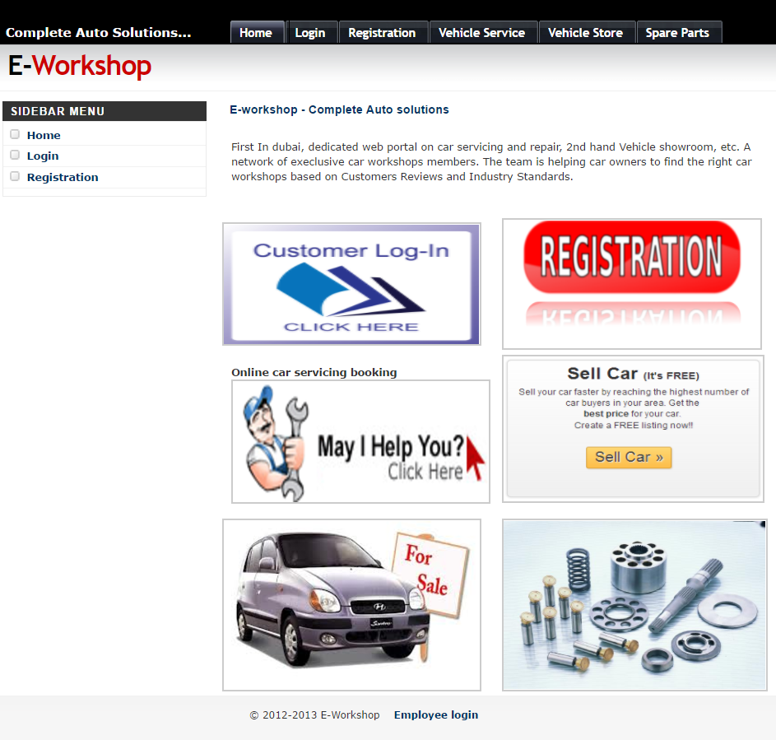

LOGIN PAGE

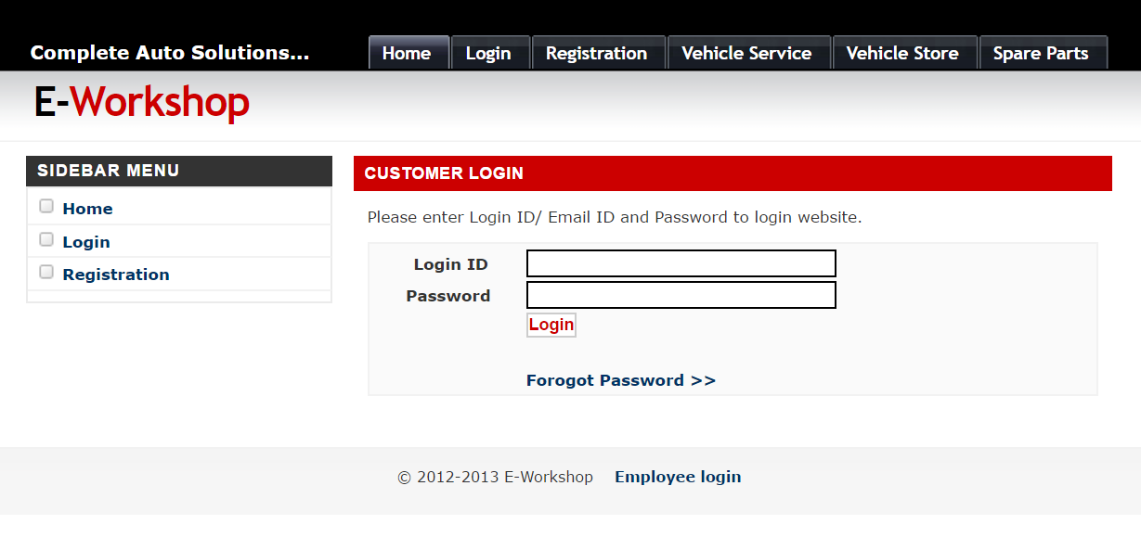

REGISTRATION

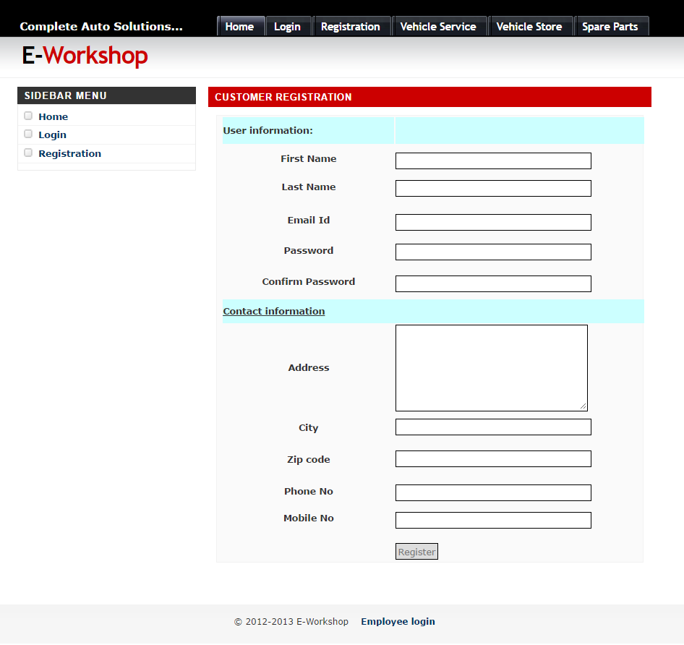

SPARE PARTS

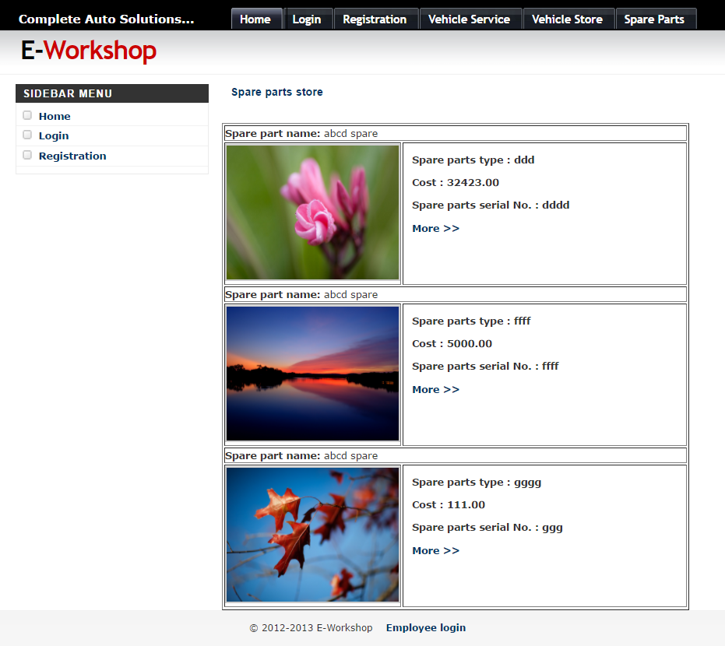

VEHICLE STORE

